11.Collaborate Using GitHub

AIM:
To understand and perform collaboration operations in GitHub such as forking repositories, cloning, making changes, creating pull requests, and resolving merge conflicts.

Procedure / Algorithm:
- Fork a Repository
  - Go to any public repository on GitHub.
  - Click the Fork button to create a copy under your account.
- Clone the Forked Repository
  - Copy the HTTPS URL of your fork.
  - Run git clone REPO_URL to download it locally.
- Make Changes and Commit
  - Edit or add files in your local copy.
  - Stage changes with git add.
  - Commit with git commit -m "message".
  - Push changes with git push origin main.
- Create a Pull Request
  - Go to your fork on GitHub.
  - Click Compare & Pull Request.
  - Submit the pull request to the original repository.
- Resolve Merge Conflicts (if any)
  - If conflicts occur, GitHub will highlight them.
  - Edit files to remove conflict markers (<<<<<<<, =======, >>>>>>>).
  - Commit and push again to update the pull request.

Code and Output:

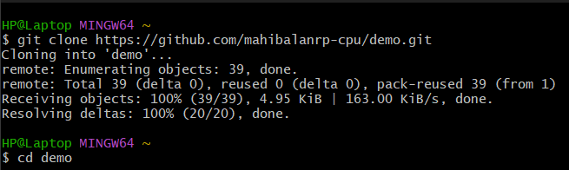
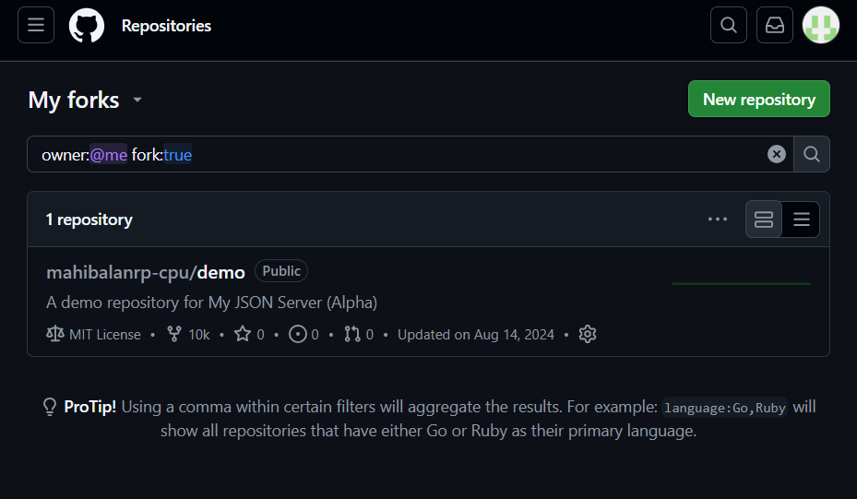

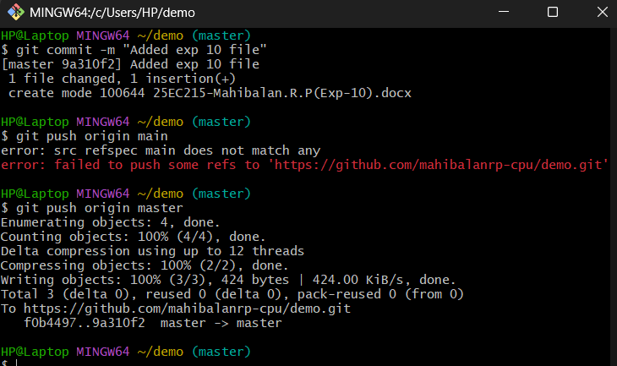
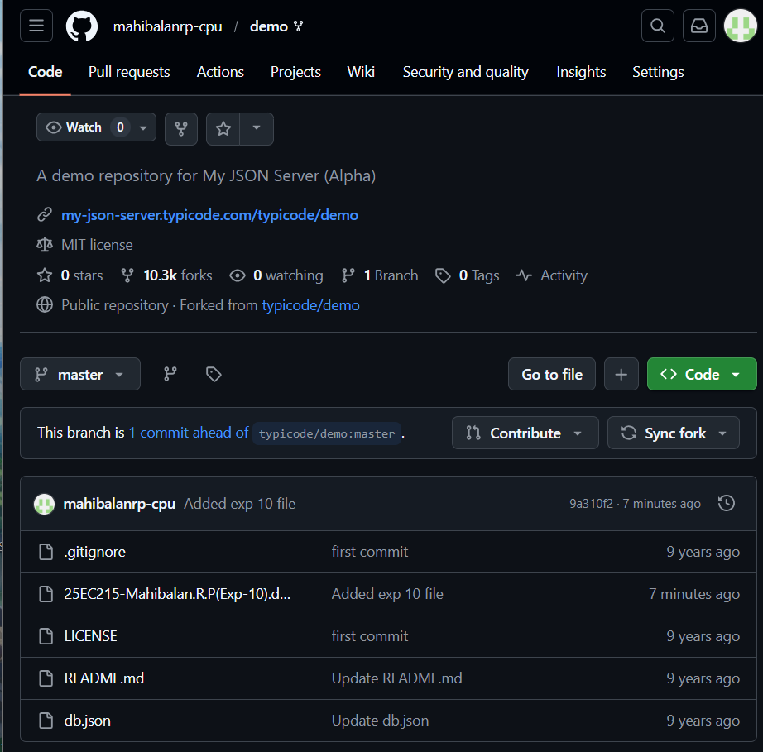

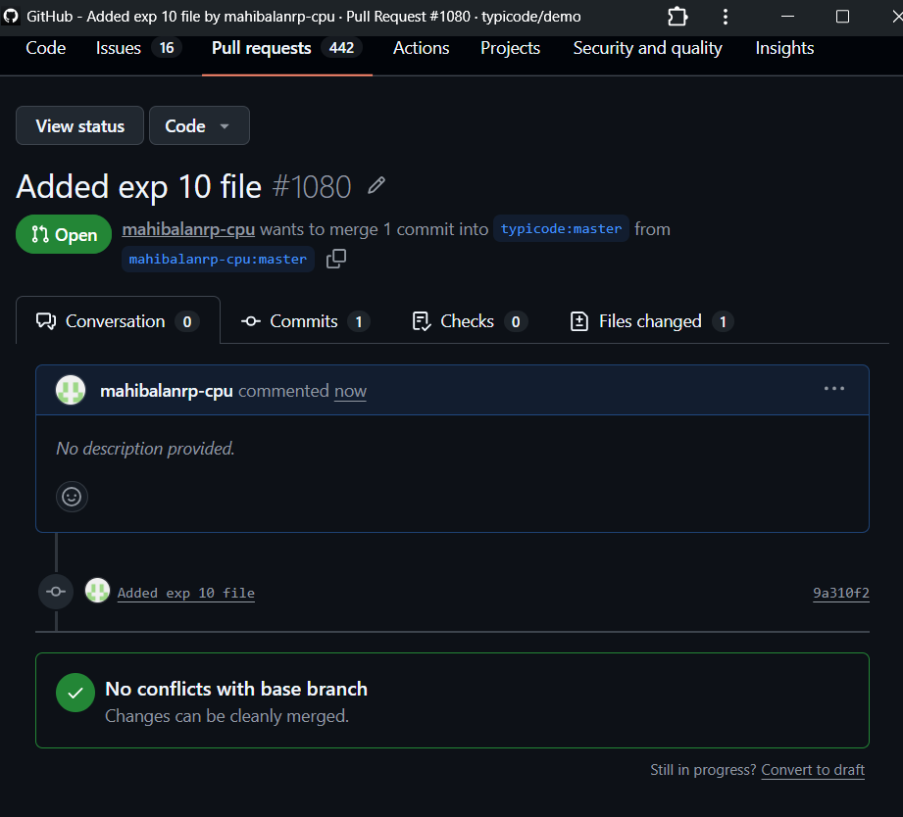

Result:
Collaboration using GitHub was successfully demonstrated. A repository was forked, cloned, modified, and a pull request was created. Merge conflicts were identified and resolved, showing how multiple contributors can work together on the same project.

